**Assignment 10.2**

Task Description#1 AI-Assisted Code Review (Basic Errors)  
• Write python program as shown below.  
• Use an AI assistant to review and suggest corrections.  
Expected Outcome#1: Students need to submit corrected code with comments

Given Code:

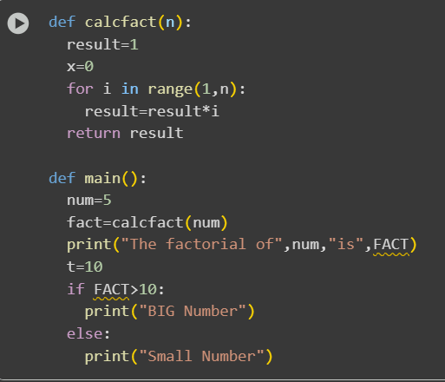

Modified Code:

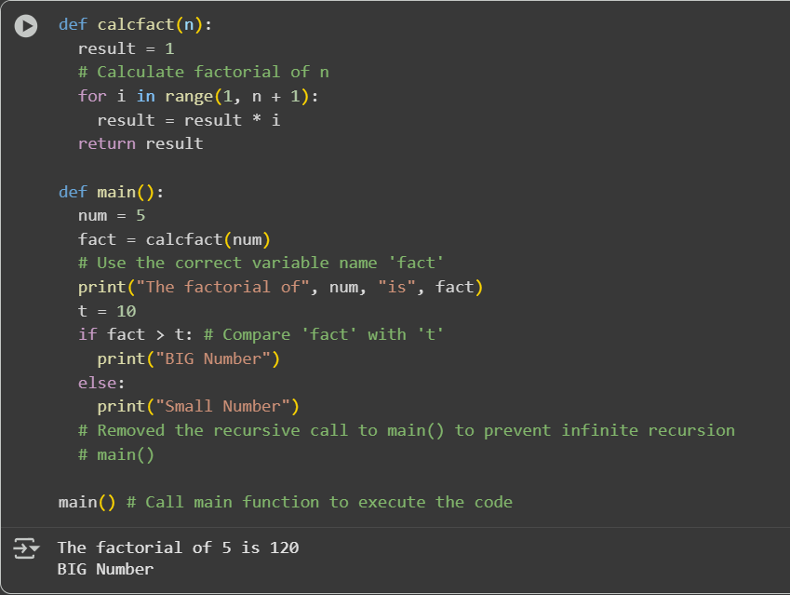

Observation: In this code we can observe that the code is corrected and modify the code in better way and also gave comments for easy understanding

Task Description#2 Automatic Inline Comments  
• Write the Python code for Fibonacci as shown below and execute.  
• Ask AI to improve variable names, add comments, and apply PEP8 formatting  
(cleaned up).  
• Students evaluate which suggestions improve readability most. one.  
Expected Output#2: Clean format python code with much readability

Given Code:

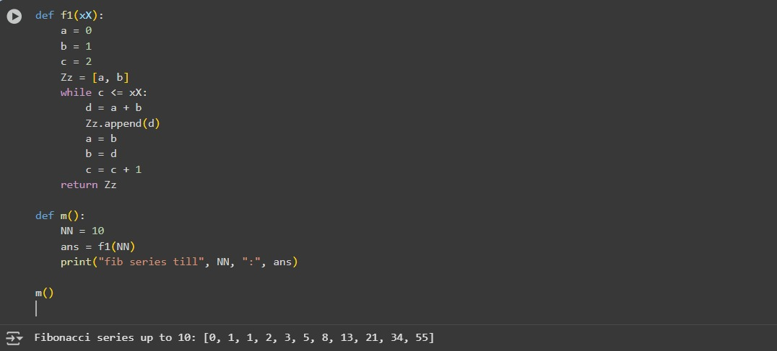

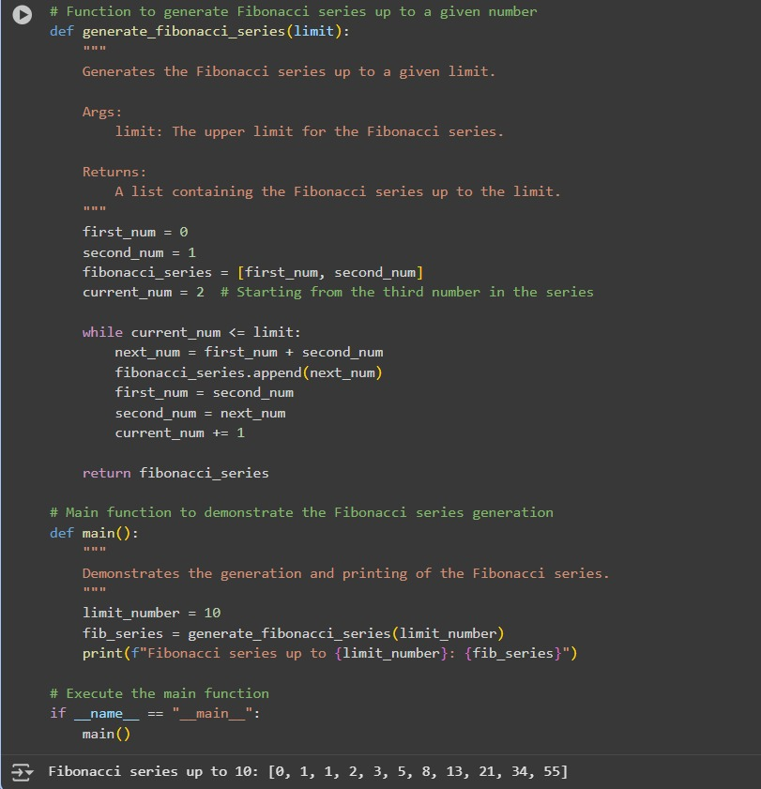Modify Code:

Observation:In this code we can see that the code is modified and made the code more understandable.

Task Description#3  
• Write a Python script with 3–4 functions (e.g., calculator: add, subtract, multiply,  
divide).  
• Incorporate manual docstring in code with NumPy Style  
• Use AI assistance to generate a module-level docstring + individual function  
docstrings.  
• Compare the AI-generated docstring with your manually written one

Student Code:

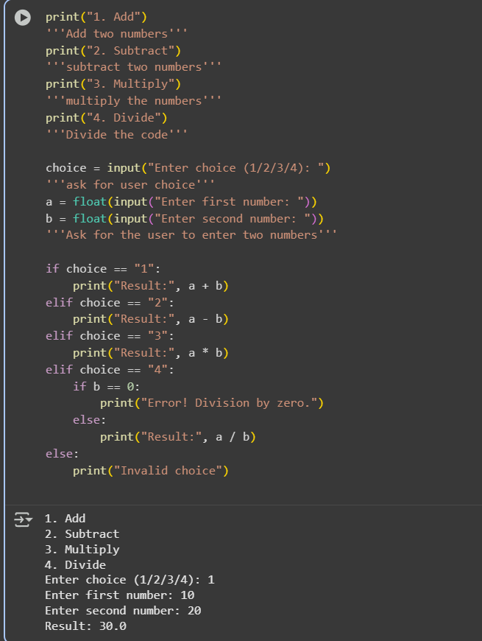

Observation: In this question I have made a code with comments and I gave my code to AI to modify the code so it modified my code by using the functions . it made code simple

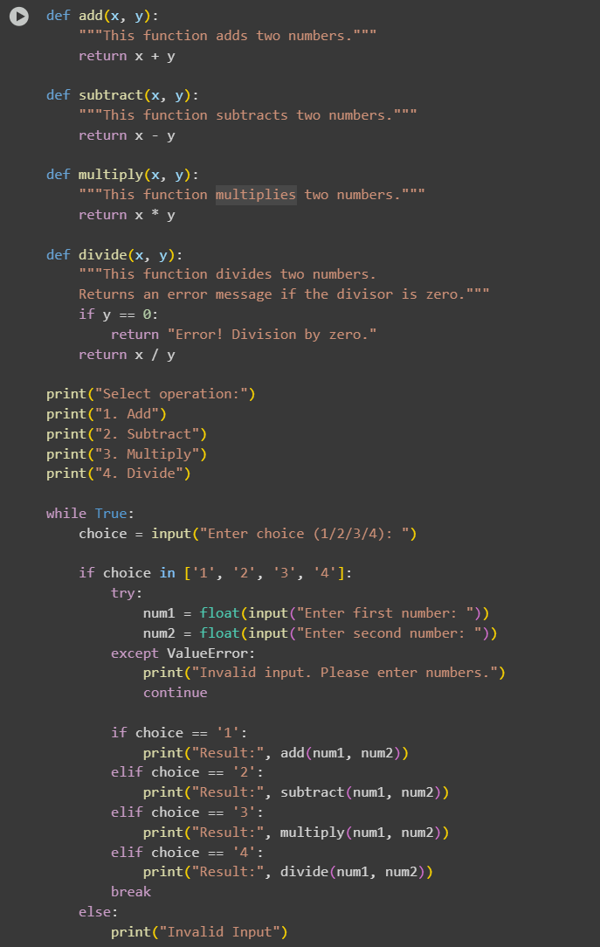AI Code:

Output:

